

*Geochemistry, Geophysics, Geosystems*

Supporting Information for

**Neogene Development of the Terror Rift, western Ross Sea, Antarctica**

C. Sauli1, C. Sorlien2, M. Busetti1, L. De Santis1, R. Geletti1, N. Wardell1, B.P. Luyendyk2

1National Institute of Oceanography and Applied Geophysics, Sgonico, Trieste (Italy).

2 Earth Research Institute, University of California, Santa Barbara, California, USA

**Contents of this file**

S1. Seismic stratigraphic correlation

S2. Faults

S3 Gridding

S4 Velocities

Figures S1 to S5B

**Introduction**

We give additional information on stratigraphic correlation, faults interpretation, gridding and velocities.

S1. Seismic stratigraphic correlation

The seismic stratigraphic interpretation included “ties” at all intersections of all the seismic reflection profiles and for all the horizons (Fig. S1). Each intersection of each horizon is a tie and we made over 50,000 ties in the Ross Sea. The MCS profile IT90-61 crosses the Victoria Land basin, which includes the Terror Rift, and intersects 11 other profiles including 9 MCS profiles (Fig. 6B, Fig. S2). Besides the sea floor there are between five and six interpreted horizons that were utilized in this study, for more than 50 ties on just this one profile. There are nearly 40 line intersections on one composite N-S profile near western Terror Rift, with ~200 horizon ties. The loop tying approach serves as an error analysis, where incorrect interpretation along a profile segment between intersections leads to obvious problems where you close the loop to the starting point by a different path. This quality check is especially important where faults are crossed. For example we interpreted a very small vertical component on faults bounding the east side of the Terror Rift in the north. The reflectors are tilted within the rift and the loop tying requires a minimum of 2 km vertical component of displacement for the 19 Ma horizon (RSU5B_vlb) across faults bounding the deeper part of the northern sub-basin of the Terror Rift (Fig. 6A).

In this paper we correlated stratigraphy using three different sets of stratigraphic nomenclature from different boreholes located in the southern Terror Rift and east of the Terror Rift in the Central Trough and in the Eastern Basin (Fig. 3). This was done because older unconformities cannot be correlated along the seismic reflection profiles across the deepest part of the rift basin to the other side, and the younger unconformities are eroded near or at the sea floor on parts of the correlation paths.

We used the RSU terminology and ages from the DSDP cores and IODP site U1521 located east of the Terror Rift. This includes the unconformities RSU6, RSU5, RSU4A from the Eastern Basin, dated at DSDP Site 270 and 272, and at IODP site U1521. RSU6 onlaps the acoustic basement on both sides of the Coulman High and is correlated in the Victoria Land Basin by comparison of the reflection pattern, with a similar interpretation to that of ANTOSTRAT (1995). RSU5 and RSU4A were correlated into the Victoria Land Basin and the Terror Rift. A newly interpreted unconformity that is prominent in the Eastern Basin (Brazell, 2017; Sorlien et al., 2016), dated about ~24 Ma in the DSDP-270 (Kulhanek et al., 2019), and a reflector called Wb, of nearly 18 Ma at the DSDP 273 well bottom, were also interpreted. RSU6 is 26-30+ Ma at DSDP site 270 (Kulhanek et al., 2019).

We used the Sorlien et al. (2016) correlation of RSU5 and RSU4A at DSDP site 273. This correlation is close to that of ANTOSTRAT (Brancolini et al., 1995a) there. The ANTOSTRAT (Brancolini et al., 1995a,b) volume is inconsistent with whether RSU5 is below DSDP site 272 or instead was cored by it. The depth of RSU5 from the grid on the ANTOSTRAT (1995) CDs and the depth from the Sorlien et al., (2016) grid are respectively 411 m and 419 m below the sea floor (bsf). DSDP site 272 cored to 440 m bsf. Thus RSU5 was cored by DSDP site 270 ( Hayes and Frakes 1975) and it was below the SITE 272 where the age at the bottom of the well is 19.23 Ma (Savage and Ciesielsky, 1983). RSU5 is ~18 Ma in the recent IODP site U1521 (McKay et al., 2019). Rocks of that age were cored near the bottom of the DSDP site 273 (Sauli et al., 2014; Savage and Ciesielsky, 1983). DSDP site 273 reached 340 m below the sea floor. ANTOSTRAT (Brancolini et al., 1995a,b) and Sorlien et al., (2016) RSU4A are respectively 279 m and 339 m below the bottom of that corehole. ANTOSTRAT (Brancolini et al., 1995a,b) and Sorlien et al., (2016) RSU5 are respectively 474 m and 565 m below the bottom of that corehole. The difference is related to the different velocity models.

The ANTOSTRAT (Brancolini et al., 1995a,b) and Sorlien et al. (2016) correlations of RSU4A and RSU5 between the (then future) site of IODP U1521 and the DSDP-273 looks reasonable on certain correlations routes, while on others one could choose unconformities that are shallower to the west. Part of this ambiguity is because of unconformity-bounded sequences that are only present on part of the intervening area. Unconformities merge and unconformities split. For this paper we use the RSU5 that is ~500 m below DSDP 273 extensively. It is older than 18 Ma by an unknown amount in the Central Trough, and presumably also in the Victoria Land Basin.

Being no age constrain in the Central Trough or in the Victoria Land Basin, beyond that they are older than Wb and younger than RSU6 and 24 Ma, the following are the estimates of their ages:

a) RSU4A (18.7 Ma) and RSU5 (19 Ma) were obtained by extrapolation at DSDP 273 below the Wb =Well Bottom with the age/depth model of Savage and Ciesielsky (1983) for no decompacted sediments and considering a constant sedimentation rate (600 m/Ma). The disconformity observed by Savage and Ciesieislki at 220 m bsf in DSDP 273 corresponds to the base of an opaque facies (likely till tongue) and the top of a stratified facies. We don’t see any evidence of major erosion (large hiatus) in the seismic facies below this disconformity in the PD 90 seismic sections in all directions across the DSDP 273.

b) RSU4A (19.5 Ma) and RSU5 (23.5 Ma) were obtained by interpolation on the eastern Terror Rift flank between the known ages of the Wb (18 Ma) to 24 Ma and RSU6 (26/28 Ma)

we have age ranges for these two unconformities (18.7 – 19.5 Ma) and (19-23.5 Ma) that make plausible the assumption of the ANTOSTRAT ages.

S2. Faults

Individual faults within the fault zones were mapped between seismic profiles in part by recognizing their activity through time. For example, one fault strand might cut through a post-Ri unconformity, while another will not. Another strand may have a large vertical component on early Miocene strata, and another may not. In part of the western Terror Rift, the down-to-east fault is one or two strands and is easy to recognize, despite the long distance between profiles. Seismic profiles that are sub-parallel to the fault strike constrain fault mapping: a given fault will either cut across these profiles or will not. Our fault interpretation in zones of closely spaced faults may not be perfect, but the interpretation is much more informed than just randomly matching up faults strands between profiles. We have interpreted the northern Terror Rift eastern border faults to have produced 2 to 3 km of vertical separation of middle and early Miocene strata (Figs. S3, S4). In contrast, ANTOSTRAT (Brancolini et al., 1995a,b) interpret little or no vertical separation across the faults on some of the same seismic reflection profiles. The large vertical component on faults was required by correlation to parts of the Terror Rift where most of the vertical component was by tilting and resulting stratal dip (Fig 6A). Our new seismic stratigraphic interpretation documents much faster sedimentation rates and subsidence rates than would be implied from the ANTOSTRAT (Brancolini et al., 1995a,b) interpretation. The MCS profile IT90-69 is the same profile presented by Davey et al., (2000) and our stratigraphic interpretation for this profile is similar to theirs. This line is relatively close to the Cape Roberts Drilling Program sites 1 through 3 (Cape Roberts Science Team, 1998, 1999, 2000) (Fig. 2).

The Transantarctic Mountains (TAM) Border Fault was locally interpreted on seismic reflection data along the west side of the Ross Sea (west side of McMurdo Sound; McMurdo Sound fault zone of Hamilton et al., 2001 and Pekar et al., 2013). It is in part inferred from the difference in Cenozoic rock uplift of the TAM including near Ross Sea/Ross Embayment (as much as 6 km; Olivetti et al., 2018) and the subsidence of the Victoria Land basin including the Cape Roberts Rift basin (Hamilton et al., 2001) and the Terror Rift. Fault zones along the boundary between the TAM and the Terror Rift have been shown on published maps (Cooper et al., 1987a; Storti et al., 2008; Olivetti et al., 2018). Our examination of seismic reflection data located on Figure S2 does not show direct evidence of a major fault or fault zone separating the TAM and the Terror Rift north of Cape Roberts between -77° and -74° latitude. It is possible that such a fault zone could exist west of these data.

S3. Gridding

It requires care to grid horizon interpretation points with close spacing along the reflection profiles, and as much as 30 to 50 km between profiles (Fig. S2). We decimated along-track point spacing to 250 m, and then used the Projection of Slopes part of the old MacIntosh software SURFACE III software to grid (Kansas Geological Survey, http://www.kgs.ku.edu/Tis/surf3/surf3Home.html). The values of data points within octants were weighted by the 4th power of their distance to a given grid point, allowing data points within octants as distant as 50 km where closer data were not present. This approach avoided most of the artifacts that standard gridding on the original point distribution produces. Using Kingdom Suite, the grids for each horizon were trimmed so they only exist where the horizon is present and interpreted. Where there is onlap, a copy of the grid of the older horizon was trimmed to match the edge of the onlapping horizon. Where there is seafloor outcrop of a stratigraphic reflector, a copy of the sea floor grid was trimmed to match the outcropping edge. The composite horizons were then re-gridded together to produce continuous regional grids. These were needed for the 3D velocity model, and for the thickness grids.

S4. Velocities

The velocity information needed for travel time to depth conversions were obtained from stacking velocities from processing of MCS data available on ANTOSTRAT (Brancolini et al., 1995a), and from stacking velocities calculated from sonobuoy seismic data retrieved in the original publications and reports (Houtz and Davey, 1973; Davey et al., 1982; Sato et al., 1984; Cochrane et al., 1992).

There was an existing Ross Sea-wide velocity model (ANTOSTRAT, Brancolini et al., 1995a). It included a 3D velocity model based on sonobuoy refraction profiles, as well as interval velocities derived from stacking velocity analysis of multichannel seismic reflection data.

We attempted to use this model for the depth conversion of our digital horizon grids. As part of this procedure in the software IHS-Kingdom Suite the interval velocity profiles were created along the seismic reflection profiles. Average velocity maps to horizons were also created. These maps and profiles were examined and found to be inconsistent line-to-line, and also in places unreasonably fast for sedimentary rocks, even considering that these rocks being overcompacted and deeply buried. In particular the interval velocities derived from stacking velocities for the Russian data were not reasonable or consistent, so these data were not used for velocities. The sonobuoy data on the ANTOSTRAT (Brancolini et al., 1995a) CDs had been passed through inverse Dix’s equation as depth and interval velocity, when it is instead correct to use time and interval velocity, yielding supposed stacking velocities that were wrong (meaningless). Therefore, we went back to the original publications and reports for the sonobuoy data (Cochrane et al., 1992; Houtz and Davey, 1973; Davey et al., 1982; Sato et al., 1984). We then created 250 depth-time charts, half at sonobuoy locations and half at selected stacking velocity points, from just east of the date line through the western shore of Ross Sea (Fig. A). Velocity points based on stacking velocities were selected for locations where the dips were sub-horizontal.

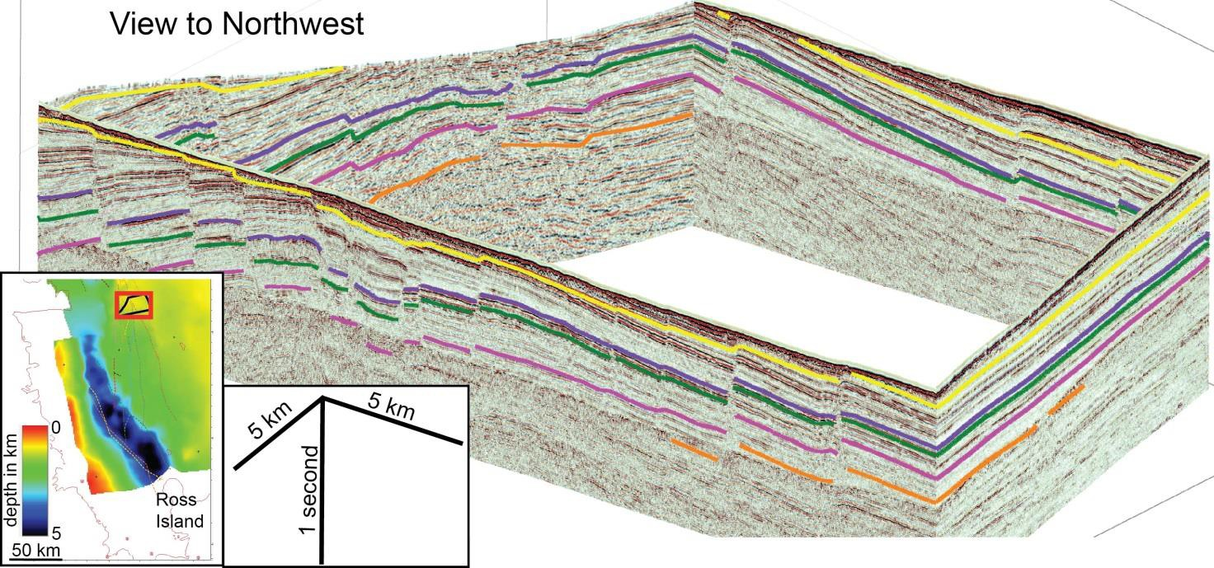

Figure S1. Fence diagram of NBP0401 high resolution multichannel seismic reflection profiles and one deep penetration Italian profile in upper left. The figure is located within the red rectangle in the inset: the inset map is of the 21 Ma-RSU5C_vlb combined unconformity. This figure illustrates “ties”, where reflections from sedimentary rock acoustic impendence contrasts are at the same two-way travel time at the same location on different profiles. Including the sea floor, there are between four and six intersections of stratigraphic horizons at each of the four line intersections for a total of 20 “ties” on this figure.

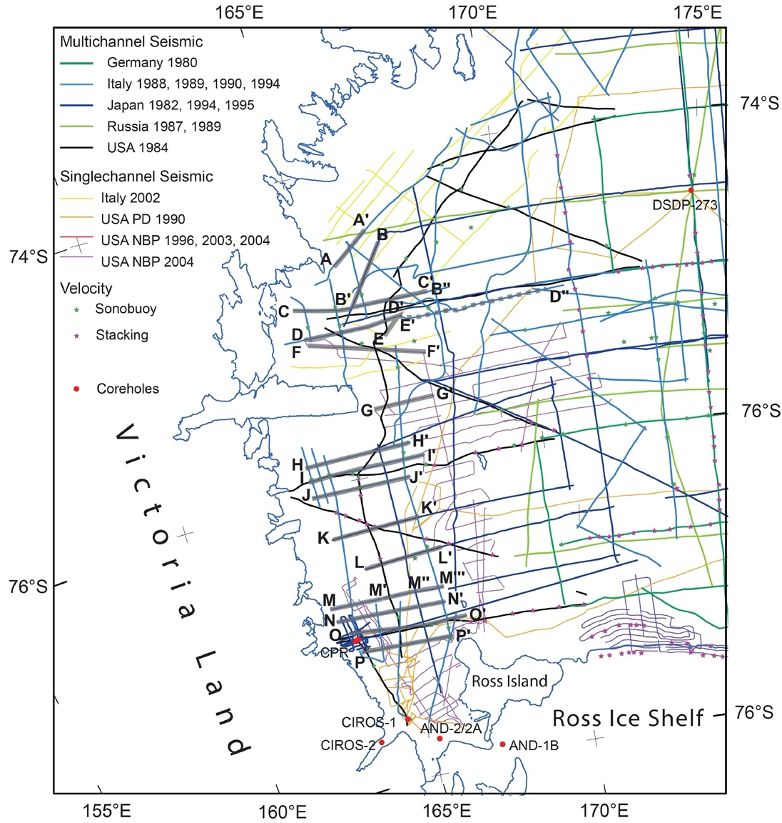

Figure S2. Location map of seismic reflection track lines, scientific core holes, and depth-time charts derived from sonobuoys (green), or stacking velocities (magenta). This is the same as Figure 2 except more profiles are located. The seismic profiles displayed on the following figures are located as A-A’ through P-P’ (E-E’ is presented as Fig. 6C in the regular figures). The densely-distributed depth-time velocity charts and thus the 3D velocity model and depth conversion cover more than 200 km to the east of this figure.

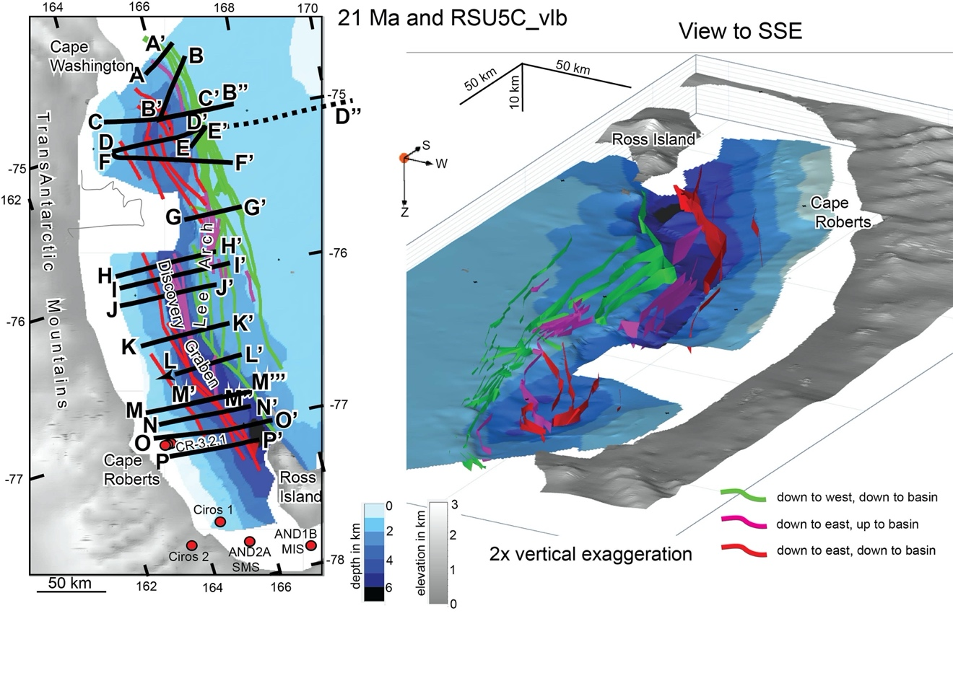

Figure S3. Plan (left) and oblique (right) views of the merged 21 Ma (west) and RSU5C_vlb (east) unconformity/unconformities. This is the same a regular Figure 5 except more profiles are located. These horizons and the faults are all displayed in depth at two times vertical exaggeration. The northern rift trends N-S while the southern rift trends NNW-SSE. A large fault(s) may be present west of these grids along the front of the Transantarctic Mountains. The colors of the faults indicate the sense of vertical motion.

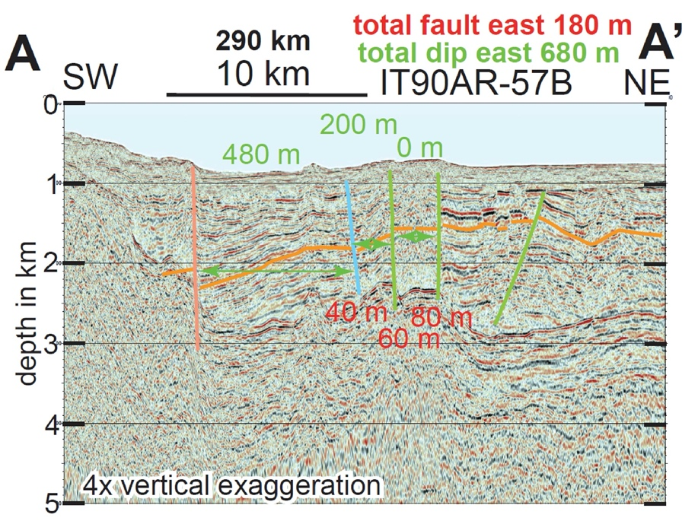

Figure S4A. All parts of Figure 4 are displayed in depth with four times vertical exaggeration. Figure 4 profiles are located on Figure S2 and S3. Faults whose vertical component of displacement is down to the west and down to the basin are green; those that are down to the east and up to the basin are magenta, those that are down to the east and down to the basin are red, and those of any type that were not mapped are cyan. We interpret a minimal amount of relative vertical motion here, near the north end of Terror Rift. Vertical relief due to dip is labeled in green, while vertical separation across faults is labeled in Red. Relief of either type that is up-to-the-basin is a negative number on the following profiles. The total fault and the total dip numbers at the top of each profile are used on the graph displayed on regular Figure 10. The distance from the southernmost profile P-P’ is given for each flank of the rift as km in black bold.

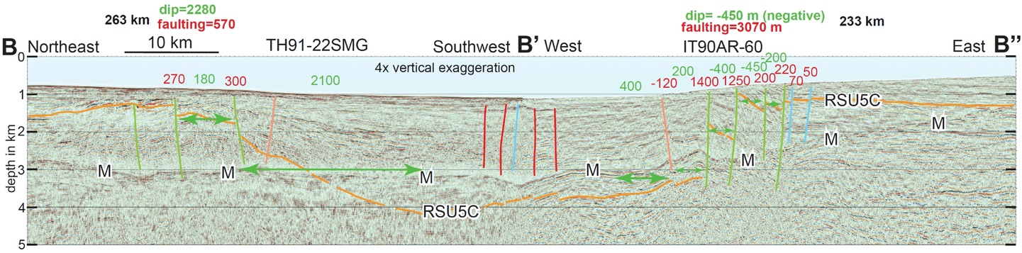

Figure S4B. Information is given in the caption to Figure S4A. This is the same profile as is shown in regular Figure 6A. Here the faults are drawn in, while on Figure 6A more stratigraphic horizons are drawn without faults. Most relief between B and B’ is by dip, while almost all of the relief between B’ and B” is by faulting.

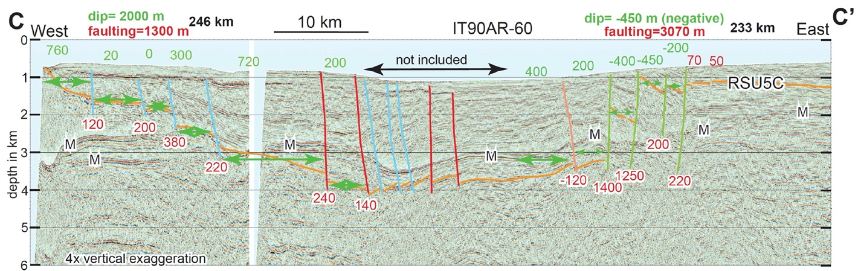

Figure S4C. Information is given in the caption to Figure S4A. Relief on the eastern flank here is almost entire by faulting. Relief on the western flank is by both faulting and dip.

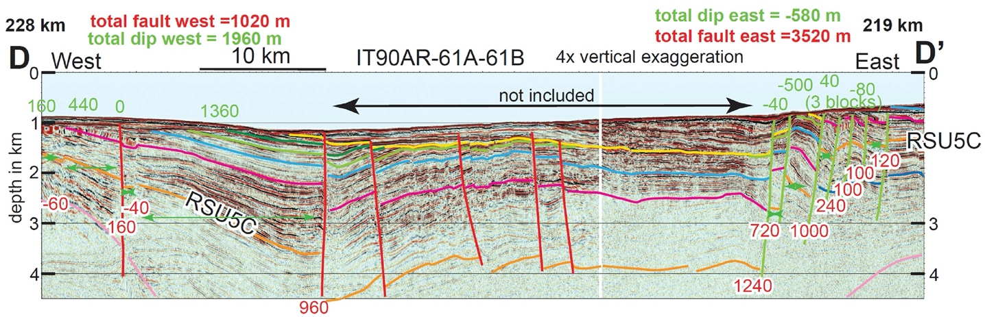

Figure S4D. Information is given in the caption to Figure S4A. This is the same profile as is shown in regular Figure 6B. Here the faults are drawn in, while on Figure 6B more stratigraphic horizons are drawn without faults. Relief on the eastern flank here is almost entire by faulting. Relief on the western flank is by both faulting and dip.

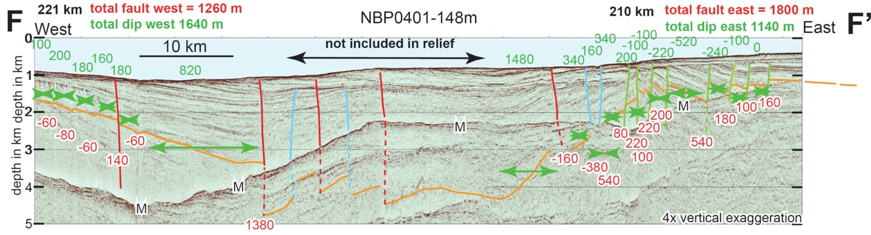

Figure S4E. Information is given in the caption to Figure S4A. This is the same profile as is shown in regular Figure 6D. Here the faults are drawn in, while on Figure 6D more stratigraphic horizons are drawn without faults. The east rift flank here is transitioning between a faulted flank to the north and a tilting, dip flank to the south. Relief on the west flank is by dip and mostly across one fault. The west end of the profile is within the regional tilt panel, so measured western relief is a minimum. western relief is a minimum. western relief is a minimum.

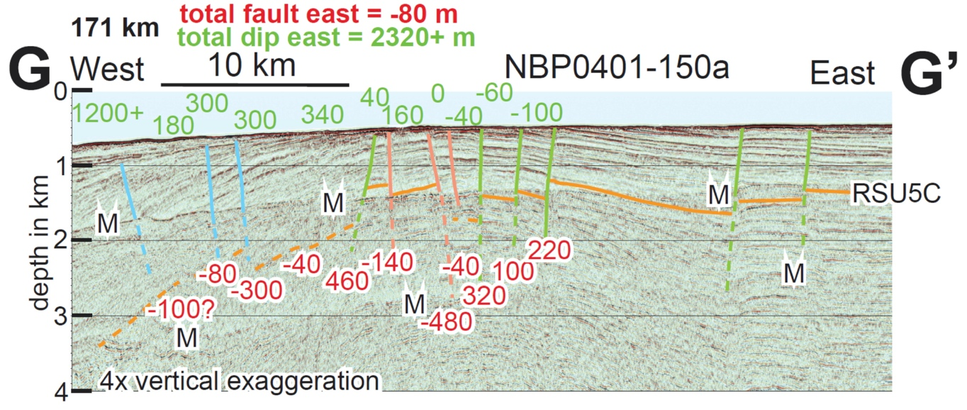

Figure S4F. Information is given in the caption to Figure S4A. This is the same profile as is shown in regular Figure 6E. Here the faults are drawn in, while on Figure 6E more stratigraphic horizons are drawn without faults. The relief is measured from the Lee Arch anticline in the center of the figure west towards the basin. This profile does not reach the deepest part of the basin so total relief is a minimum. Down-to-the-basin relief is mainly by dip.

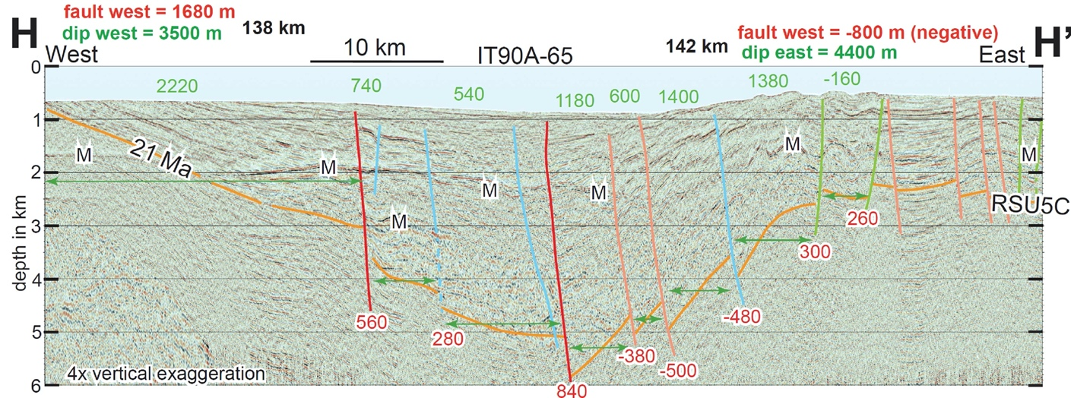

Figure S4G. Information is given in the caption to Figure S4A. Relief between the basin and Lee Arch on the eastern rift shoulder is by dip. Relief on the western flank is mostly by dip but is partly by faulting. The west end of the profile is within the regional tilt panel, so measured western relief is a minimum.

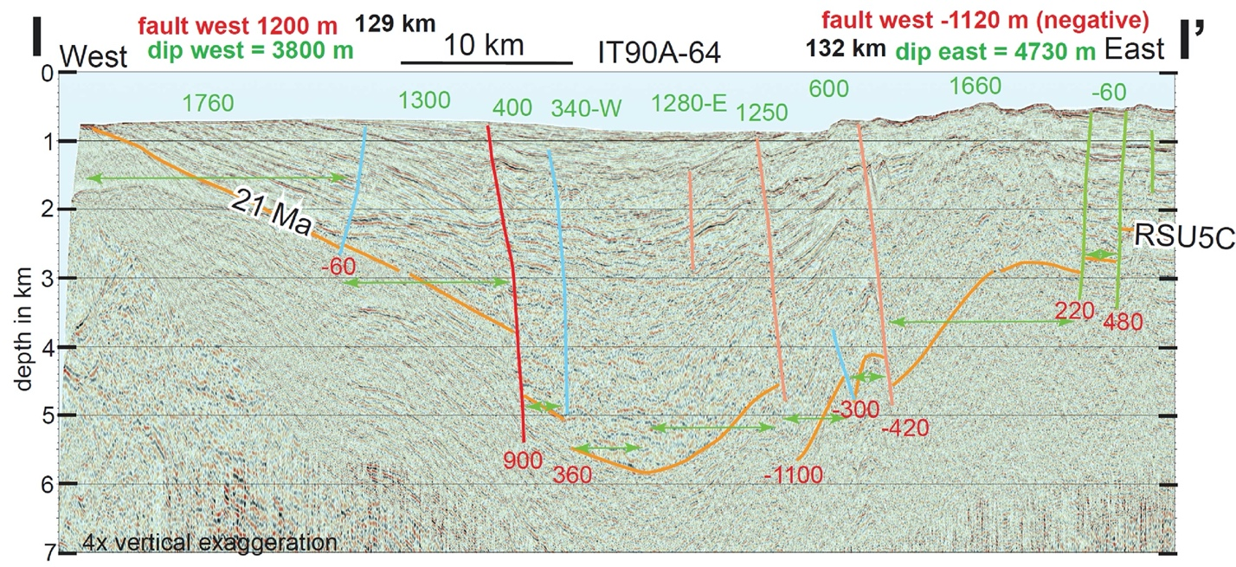

Figure S4H. Information is given in the caption to Figure S4A. Relief on the east flank is by dip, and on the west flank relief is by dip and across one narrow fault zone that may be primarily right-lateral, and that is imaged on the following profiles. The west end of the profile is within the regional tilt panel, so measured western relief is a minimum.

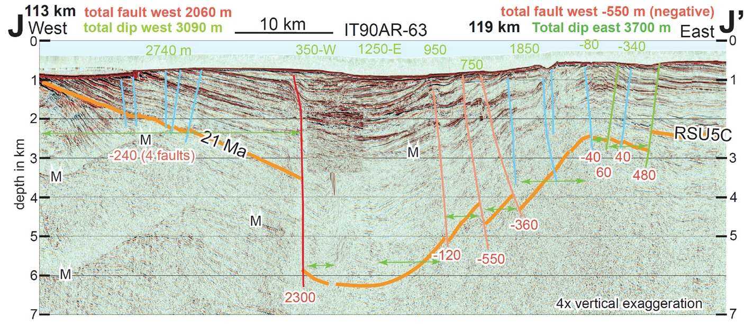

Figure S4I. Information is given in the caption to Figure S4A. This is the same profile as is shown in regular Figure 6F. Here the faults are drawn in, while on Figure 6F more stratigraphic horizons are drawn without faults. The west end of the profile is within the regional tilt panel, so measured western relief is a minimum.

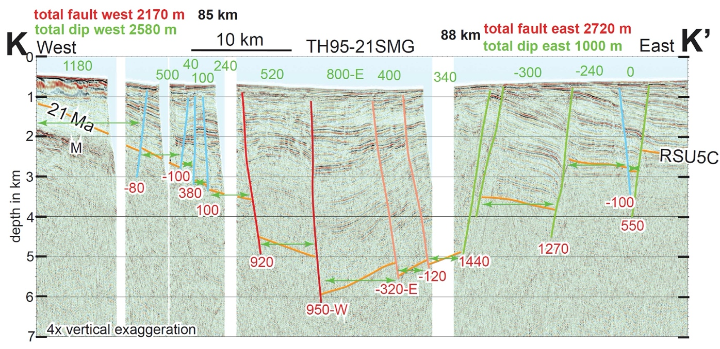

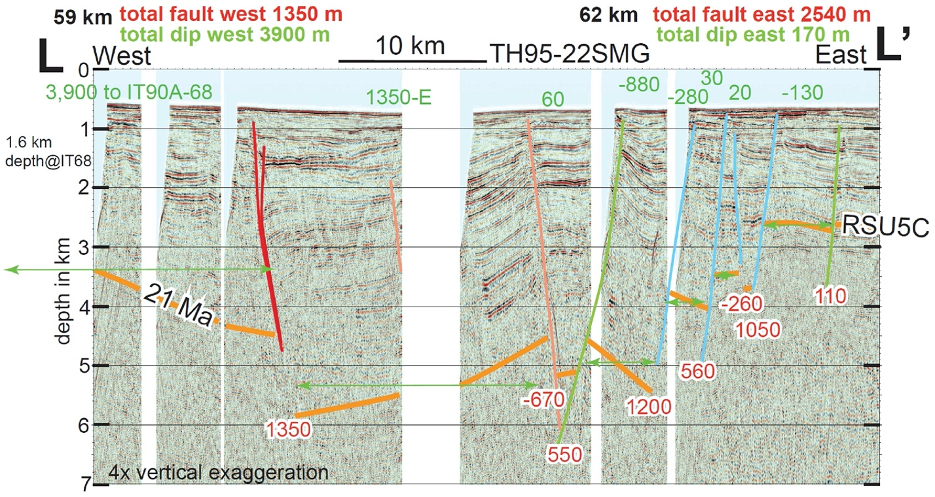Figure S4J. Information is given in the caption to Figure S4A. This profile is in the transition from eastern relief being accommodated by dip to the north and by faulting to the south. The west end of the profile is within the regional tilt panel, so measured western relief is a minimum.

Figure S4K. Information is given in the caption to Figure S4A. The western relief includes the depth of the 21 Ma orange horizon to the west of this profile. Here, the eastern flank of the rift is within the southern faulted segment (Fig 9).

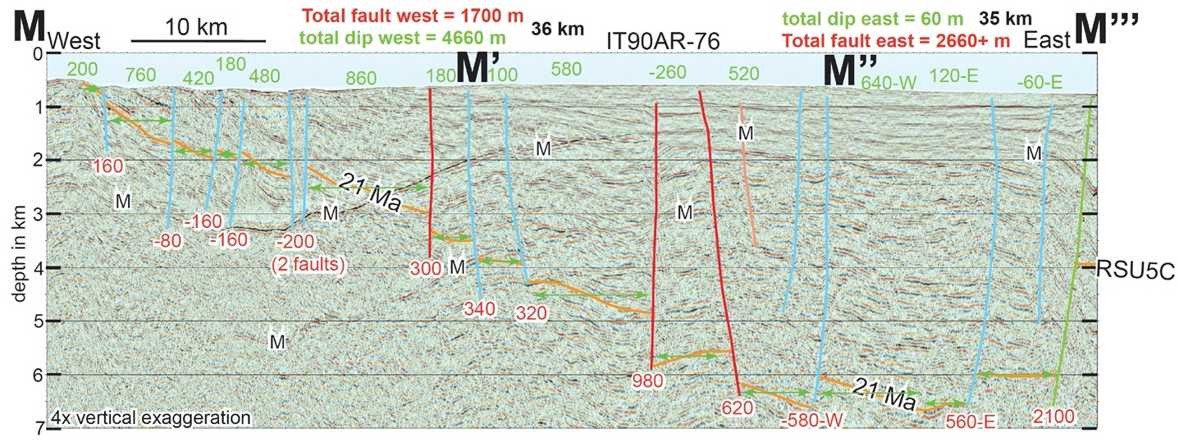

Figure S4L. Information is given in the caption to Figure S4A. There is likely additional relief to the east of this profile. The pair of faults drawn as red near the middle of the profile are likely strands of a right-lateral strike-slip fault zone.

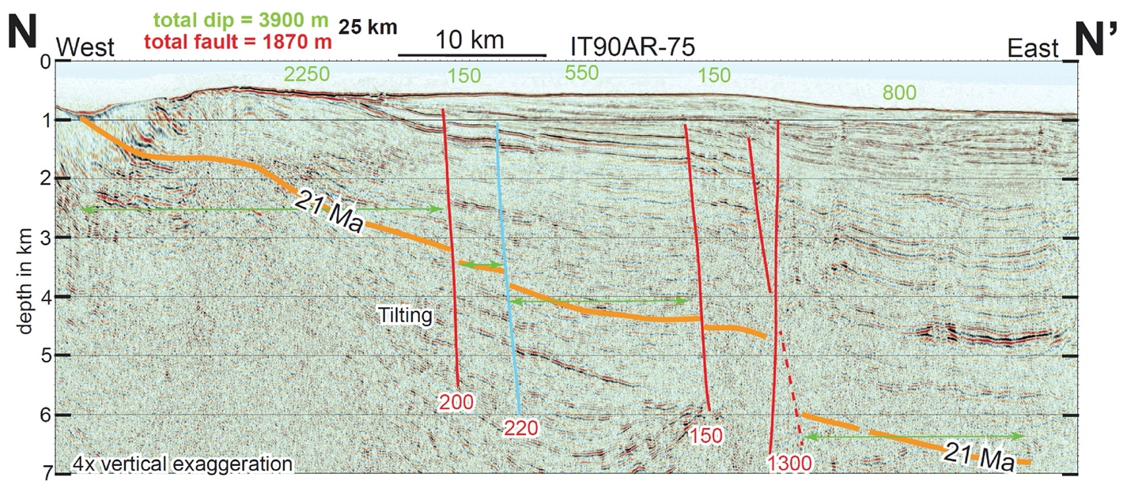

Figure S4M. Information is given in the caption to Figure S4A. The relief due to dip is increasing to the south, while the relief due to faulting decreases to the south. This profile ends before crossing the large eastern boundary fault seen in Figure S4N.

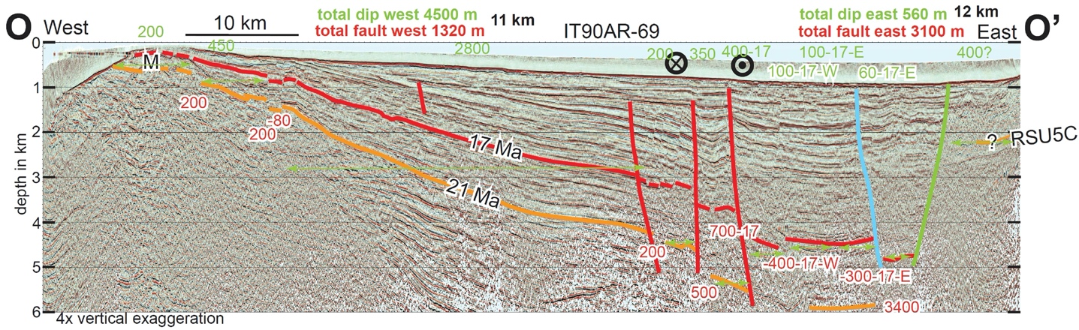

Figure S4N. Information is given in the caption to Figure S4A. This is the same profile as is shown in regular Figure 6H. Here the faults are drawn in, while on Figure 6H more stratigraphic horizons are drawn without faults. Relief of the 17 Ma horizon across faults was used in the deepest part of the basin because the 21 Ma fault relief is poorly imaged. The structure near here is a half graben tilting about a horizonal axis.

# 

Figure S4O. Information is given in the caption to Figure S4A.

# Henrys et al 2007



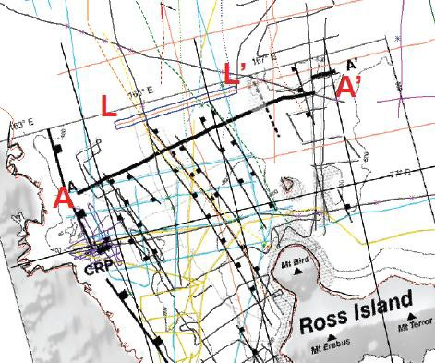TH95-22SMG (L-L’) 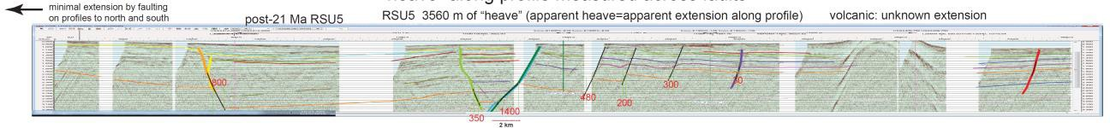

Figure S5A. Extension since 21 Ma measured on L-L’ (Fig. S4K) by summation of heaves. This is the horizontal component of the dip-slip component. We measure 3.6 km of extension plus an unknown amount of extension across the volcanic feature. The location of A-A’ from Henry et al (2007) is shown on the base map.



Figure S5B. Extension since 21 Ma measured on D-D’ (Fig. S4D) by summation of heaves. This is the horizontal component of the dip-slip component. We measure 3.6 km of extension.